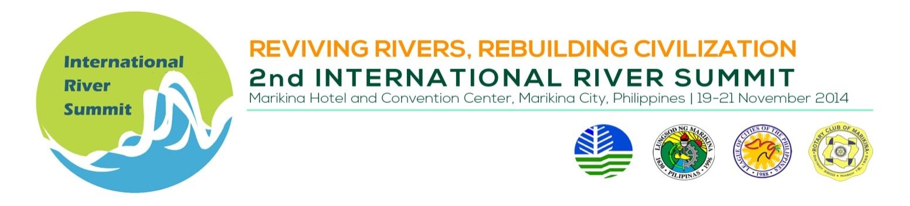
PLENARY SESSION DAY 2

Venue : Convention Center Plenary Hall

Date/Time : November 20, 2014, 9:00 – 12:00 NN

TIME | TOPIC
9:00 – 9:05 AM | Key Highlights of Summit Day One
9:05- 9:35 | Agricultural Productivity optimization in deficit water condition in Yamuna Basin | Prof. Rajendra Kumar Isaac , Sam Higginbottom Institute of Agriculture Technology and Sciences, Deemed University, Allahabad, U.P. India
9:35-10:05 | Resilience Building in River Management | Ms. Bantitha Khantisidhi, Project Manager, Flood Management and Mitigation Programme, Mekong River Commission (Cambodia)
10:05-10:25 | BREAK
10:25 – 10:50 | Building Partnership for Environment  Management of Water Bodies in Southeast Asia | Mr. Adrian Stephen Ross, Program Director, UNDP - Partnerships in Environmental Management for the Seas of East Asia (PEMSEA)
10:50- 11:20 | Recent Advances in Australian River Management | Mr. Terry van Kalken, Head, Water Resources Dept, DHI Malaysia, Malaysia
11:20-11:50 | Totally Thames Festival London | Mr. Adrian Evans, Festival Director & Pageant Master, Totally Thames London, United Kingdom of Great Britain and Northern Ireland
11:50 – 12:00 | OPEN FORUM
12:00 – 1:30 | Lunch at Al Fresco Dining Hall, Marikina Hotel
1:30- 5:00 | THEMATIC SESSIONS | Marikina Hotel Breakout Rooms
6:00 | APPRECIATION NIGHT (by invitation only)

